The benchmark professional exhibition for the distribution of garden products and equipment for over 20 years, JDC Garden Trends will be held in Marseille from March 25th to 27th. CF group, key player in the pool industry, will be exhibiting its new products for pools, equipment and water treatment ( Booth F07 - Hall 1). Innovative flagship products for a more sustainable and environmentally-friendly pool will be presented at the show...
CF GROUP ATTENDS THE
JDC GARDEN TRENDS FAIR
FOCUS ON SHOWCASE PRODUCTS FOR A MORE SUSTAINABLE SWIMMING POOL
Press release
March 2025
CF group is an undisputed leading reference for retailers, both through its own brands such as EDG by Aqualux and CF, and through its role as a specialist manufacturer of water treatment products..

The pool, a key garden highlight
For many French people, having a garden is great, but having a swimming pool in the garden is even better! According to the French Federation of Pool and Spa Professionals, there are over 3.5 million private swimming pools in France.
Garden product and equipment retailers must therefore adapt to this growing trend, and stock their aisles with products that meet these expectations. To help them find the right products and the latest innovations in this market, the JDC Garden Trends fair is the place to be to meet the CF group teams.

The JDC trade show, a reminder of CF group's commitment to the environment
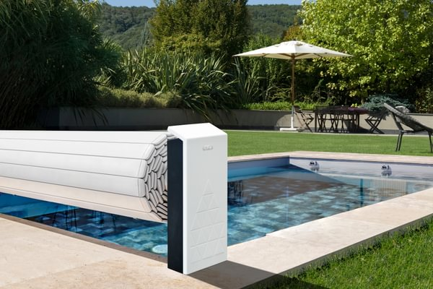
On its booth F07 - Hall 1, CF group will be showcasing its innovative and particularly environmentally-friendly products in the swimming pool industry, including :
- CF Pure Serie cover, the elegant, durable above-ground cover that combines :
  - Discreet, thanks to a minimal footprint
  - Unique design to match any outdoor environment;
  - Sleek design, with a textured matt-white faceplate and distinctive decors that blend perfectly with the matt-black base;
  - Durability, thanks to 100% recyclable end-stands made from recycled materials: these end-stands are manufactured locally, from sourced materials (100% of suppliers are French and located less than 200 km from the Brittany manufacturing plant).

Designed for rectangular pools from 2 x 3 m to 5 x 10 m (including stairs), it complies with the NF P90-308 standard and offers a wide choice of colors. Manufactured in France and guaranteed for 2 years, it is also compatible with the LivePool Cover app, enabling it to be operated remotely. You can open or close the cover via your smartphone using this application.

Download product images and brochure here .

- The launch of a new Chemicals range from the CF brand on the French market: this range is offered in recyclable cardboard packaging instead of plastic, to help reduce the carbon footprint. Manufactured in Europe, it incorporates high-quality molecules, ensuring clear, healthy water.
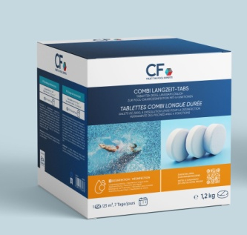
CThis new approach is perfectly in line with the CF brand's ambition to care for water and lim impact on the environment, without compromising the safety of bathers.
The new cardboard packaging also meets an educational requirement: it is designed to enable users to quickly and easily understand how to use the products and how to integrate them into the water treatment process, thanks to a colored scale indicating the order of the steps.
This range includes 6 references that cover all disinfection needs for all pool sizes, all for flawless water quality.
On each product, a QR code link is integrated to access the Livepool Care web application, which measures and analyzes pool water quality in real time. Thanks to this innovative technology, users are given precise, real-time information on the different products to use, and the filtration time to adapt according to the results obtained from the strips.
Equipped with artificial intelligence and a highly accurate calculator, this tool enables a complete analysis to be carried out in record time, and provides recommendations on the products needed for proper pool maintenance, like a connected pool assistant.
Our teams have developed this innovation to enable everyone to obtain personalized recommendations on a user-friendly interface, and to make pool treatment ever simpler.
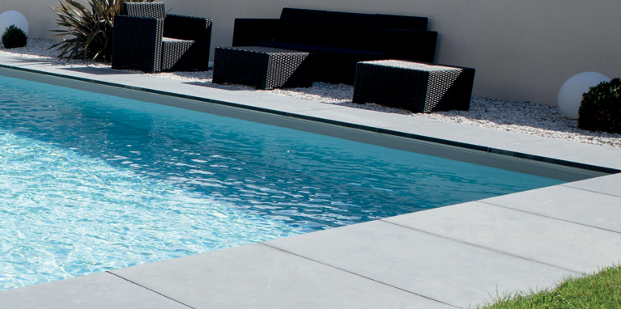
- CF PRESERVEO, the all-in-one solution designed to enable all private customers to enjoy the pleasures of a more responsible swimming pool in their own garden.
- - This solution includes all the equipment needed to build, operate and maintain a swimming pool, while respecting the planet and controlling costs (highly insulating structure, pre-assembled water- and energy-efficient filtration unit, overflow water recovery tank, phthalate-free liner).
In terms of aesthetics, the CF PRESERVEO pool kit features a sleek, contemporary design identical to that of traditional masonry pools. The rectangular pool featuring an internal corner stairs is available in two elegant liner colors (steel gray or light blue), blending perfectly with all types of landscaping for a harmonious effect.

With this kit, CF makes it possible for any enthusiastic DIYer to create their dream pool: the perfect solution for unforgettable summers, without compromising on comfort or elegance. Available in 4 sizes: 4 x 2.5 m; 6 x 3 m; 7 x 3.5 m; 8 x 4 m and for 1.5 m flat bottoms, with 2 possible positions for the corner stairs.

Download product images and brochure here.

All these products, and many more, can be found on booth
CF group F07 - Hall 1 at JDC Garden Trends.

About CF group
CF group is a family-owned European group, specializing in equipment for private and public swimming pools and water treatment. Thanks to the daily commitment of its more than 1,000 employees and the strength of its French and European production sites, CF group strives to offer its customers an exceptional experience. With its 10 strategic brands on the French market, CF group has become a major player in the pool sector, advocating and developing a more responsible pool that contributes to the health and well-being of users. To find out more: https://www.cf.group/fr/



